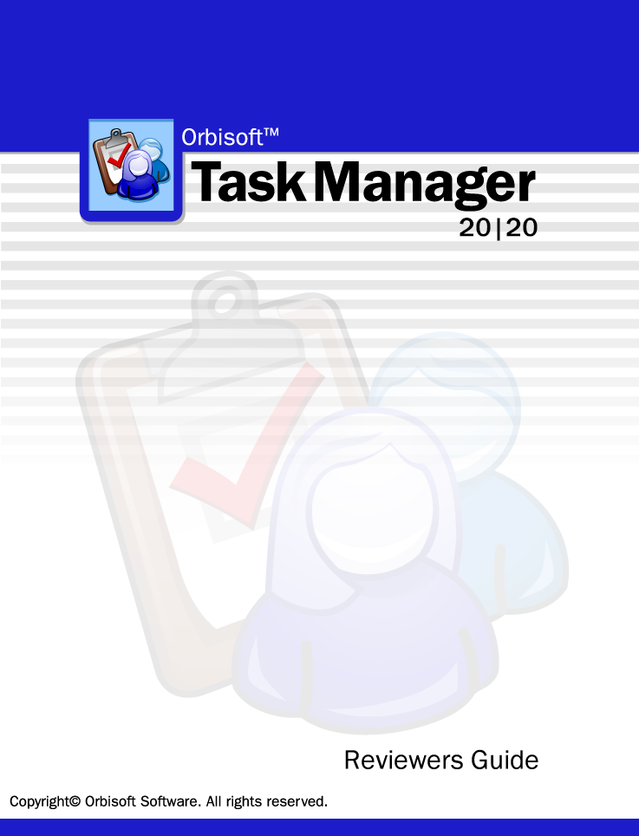
Microsoft, Windows, Vista, Windows 7/8 are either registered trademarks or trademarks of Microsoft Corporation in the United States and/or other countries. Wise Installer® is a registered trademark of Wise Solutions Inc. All other trademarks or registered trademarks are the property of their respective holders.
Orbisoft, Orbisoft Task Manager, Orbisoft Task Manager 20|20, and Task Manager 20|20 are trademarks of Orbisoft Limited.

Revision 9.00

Table of Contents

Introduction 5
Why Task Manager? 5
What is Task Manager? 6
About Orbisoft 8
Works With Microsoft® Windows XP, Windows Vista®, Windows 7® 8
Microsoft® Windows® Catalog Availability 8
Sample Feature Highlights of Task Manager 20|20™ 9
Flexibility with User-Customizable Task Entry Forms 9
Time-Saving with a Quick Task Close-Off Form 10
Flexibility with User-Definable Task Fields 11
Task Entry Time Saving with Quick-Entry Templates 12
Flexibility with User Task-Lookup Field Selection 13
Manager-Controlled Team Member Selection 14
Fast, Flexible, and Presentable Reporting 15
Powerful Reports with Report Options and Team Member Filters 16
View Task Details 18
Team Workload Overviews 19
Analysis Tools 20
Interactivity with Task Calendar Views 21
Improve Productivity with Auto-Scheduling 26
Interrelate With Other Task Sources 27
Activate Task Security: Program Permissions 29
Activate Task Security: Field Permissions 30
Activate Task Security: Task View Permissions 31
Use Built-in or Customized Email Reminders for Task Events 32
Comprehensive Help, User Manual, Online Help And User Knowledge Base 34
Sample Users 35
Task Manager 20|20 Online Information 40
Online Tutorial 40
Online Frequently Asked Questions (FAQ's) 40
Online Product Information 40
Online Support Information 40
Free 45-Day Trial Download 40
Downloadable Color User Manual 40
Support Knowledge Base 41
User Comments 42
Pricing 46
Contact 47

Introduction
Welcome to the Task Manager 20|20 Reviewers Guide™!

Why Task Manager?
In today's challenging work environment, you need a way to track tasks and jobs for your organizational teams — and for yourself.
Missing critical deadlines, under-resourcing task workloads and being unaware of daily team activities can have an effect on office productivity, managerial decision-making and general work efficiency. These factors in turn can impact directly on financial performance, staff morale and even customer reputation.
Orbisoft addresses today's task-management needs with its latest, easy-to-use, and award-winning Task Manager 20|20™ software.
Use Task Manager 20|20 to manage workloads easily, quickly, and efficiently, closely monitor task deadlines, allocate work fairly between team members, and track overall team progress.
We hope you enjoy the benefits of using Task Manager 20|20 and realize its many time saving advantages!
Take time now to use this Reviewers Guide to walk-through Task Manager's features and functionality.
In addition:
- Consult the Task Manager User Manual available at www.orbisoft.com/download to get a more in-depth explanation of a particular Task Manager feature.
- Orbisoft's pre-sales support team is available to answer any questions you might have.
We are also available to give specific advice on how Task Manager might best be used in your organization to meet your particular task-management needs. Contact the pre-sales support team at pre-sales@orbisoft.com.
- If you haven't already done so, you can download a free fully functional 45-day demonstration version of Task Manager at www.orbisoft.com/download.

Be sure to visit http://www.orbisoft.com for latest product news and information.

What is Task Manager?
Task Manager is a database program that helps manage and keep track of individual or team tasks, jobs, and projects.

Whether you're working by yourself, or are part of
- a small/medium size company,
- a large corporation or enterprise,
- a professional organization,
- local/state/federal government or military, or
- a non-profit or educational organization,
Task Manager is designed to be a flexible, easy-to-use solution to meet all of your task- management needs.
Task Manager is built around a workflow concept — tasks that come in are logged, progressive task information is added or edited over time, tasks are reported on (and analyzed if required), and finally tasks are closed off.
With such a process-view of the task cycle as a basis, Task Manager has built-in features to provide you with the easiest (and fastest) methods for task data entry and task editing.
Task Manager also provides built-in and customizable task monitoring, reporting, and analysis options to fit your unique work environment such as automatic email reminders, customizable work reports, charts of work allocation and progress, and even export and linking to other third-party applications.

Task Manager Features
Tasks | Overall Work Days Outstanding
Recurring Tasks | Integration
Task Progress Monitoring | Export to HTML, Microsoft Word®, Excel®, Text, and Access Snapshot®
User-Definable Task Fields (up to 40) | Synchronization with Microsoft Outlook®, Pocket PC®, Palm® (requires Microsoft Outlook® 2002/3 or later)
OLE Object Fields | ODBC (Open Database Connectivity) Compliance
Advanced Task Filtering | Direct Emailing of Reports
Calculation Based Fields | Network
Task Quick Entry Templates | Stand-Alone or Multi-User
Auto Field Lookup | Up to 255 Concurrent Users per Workgroup, Multiple Workgroups
Time Management | Tools
Optional Time Budgeting | AutoCorrect®
Absolute Time or Fee % Budget Entry | Automatic Data Backup
Automatic Time Budgets | Automatic Email Reminders
Automatic Scheduling | Security
Reports | Optional Program, Field, Task View, and Table Security
Customizable and Pre-Loaded Reports | Optional Dynamic User Security
Graphical Task Calendar View | Help and Support
Unlimited User-Creatable Reports | Built-in Contextual and 'What's This' Help, Help Contents, Index, and Search
Multiple Selection Criteria | Getting Started Tutorial
Analysis | User Manual
Workflow Analysis | Online Frequently Asked Questions and Knowledge Base
Task Statistics | Orbisoft Support Helpdesk

About Orbisoft

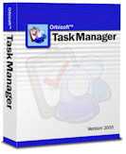
Works With Microsoft® Windows 7/8®, Windows Vista®, Windows XP

Sample Feature Highlights of Task Manager 20|20™
- Walk-through the following feature highlights of Task Manager 20|20:

Flexibility with User-Customizable Task Entry Forms

- Quickly navigate through live tasks with convenient, easy-to-read task entry forms. All forms have built-in intelligent field defaults to reduce data entry time. Notes can be zoomed, dates can be selected via pop-up calendars and team members to participate on a specific task or job can be chosen.

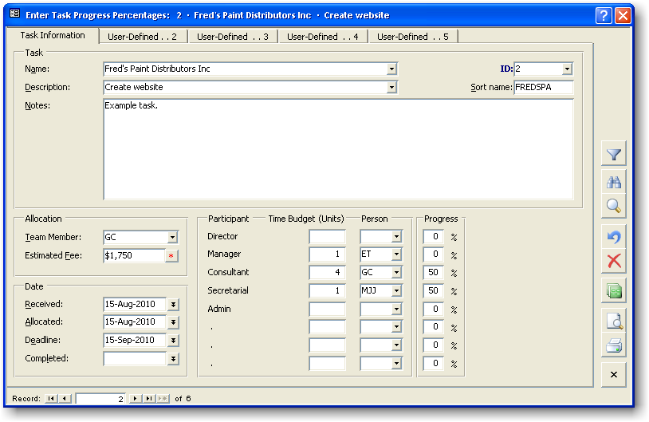

Time-Saving with a Quick Task Close-Off Form

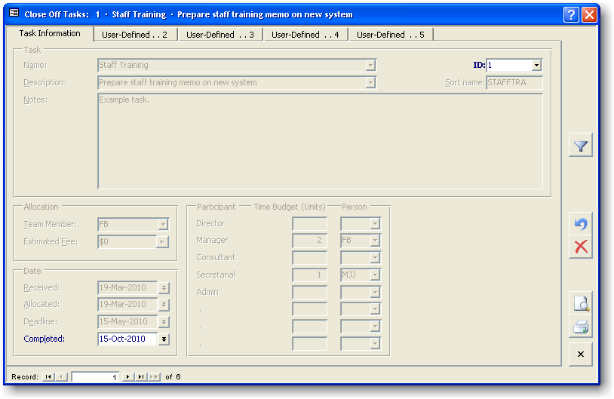

- Reduce data-entry time closing-off personal or group tasks with automatic task close-off screens.

Flexibility with User-Definable Task Fields

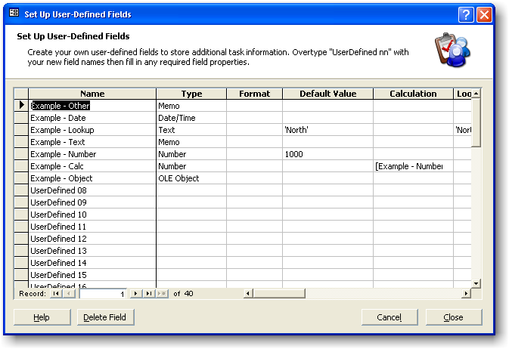
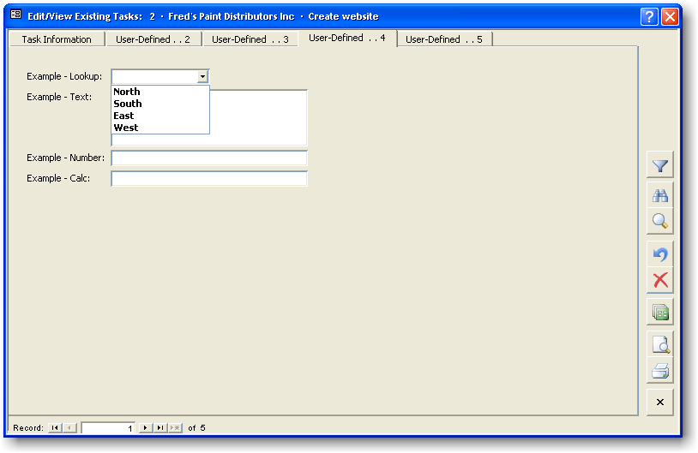

- Allow users to create their own user-defined task fields specific to their own workgroup or department. (In addition to being able to create Text, Number, Date/Time, Yes/No and Memo field types, users can also create Object type fields, linking or embedding them directly on a task form. Object type fields can include Microsoft® Excel®, Word®, PowerPoint®, sound bite/memo, picture, video, chart, drawing and many other data types.)

Task Entry Time Saving with Quick-Entry Templates

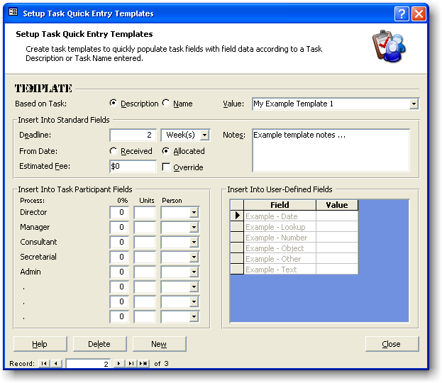

- Use quick-entry templates to speed up task data entry for all team members.

Flexibility with User Task-Lookup Field Selection

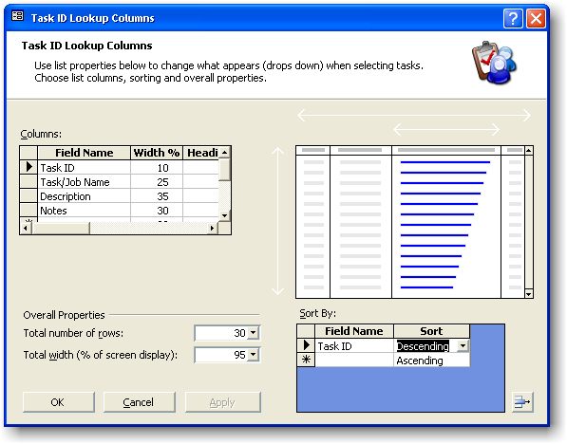

- Let individual users customize how they see their own or other team members' tasks.

Manager-Controlled Team Member Selection

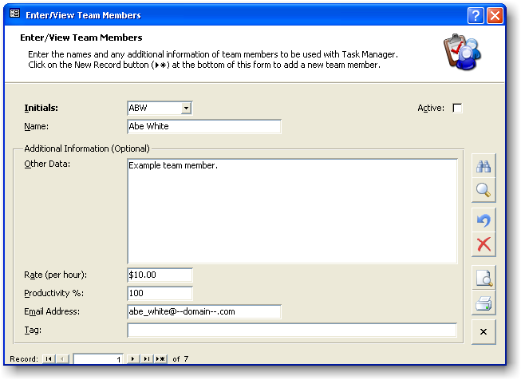

- Managers can quickly decide and enter relevant team members for their area.

Fast, Flexible, and Presentable Reporting

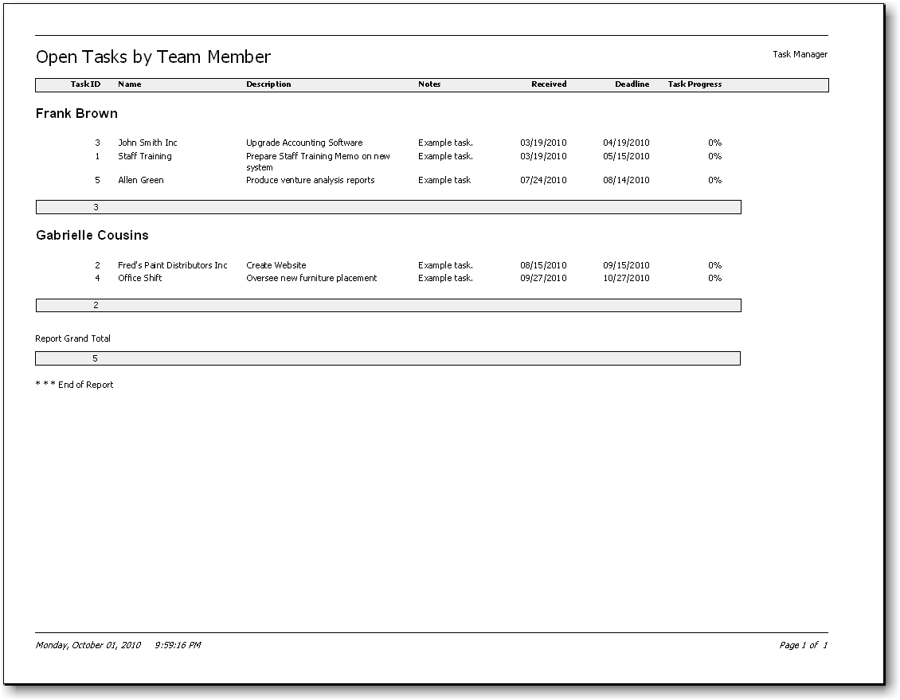

- Quickly choose and preview task output reports. Reports run in seconds regardless of database size.

Powerful Reports with Report Options and Team Member Filters

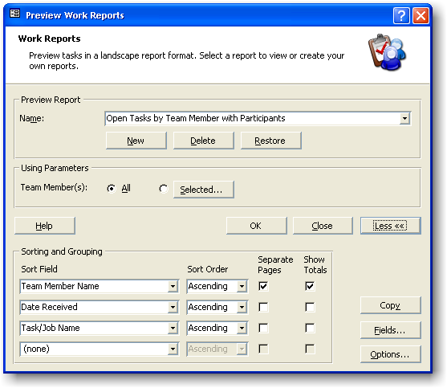

- Create new or use existing built-in work reports to track tasks.
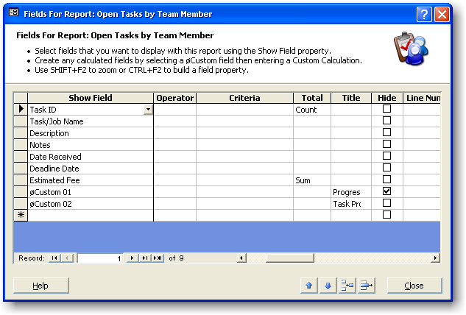

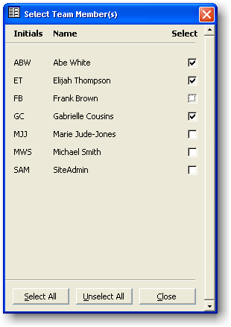

- Decide on work report sorting, grouping, fields, options and team member filters.

View Task Details

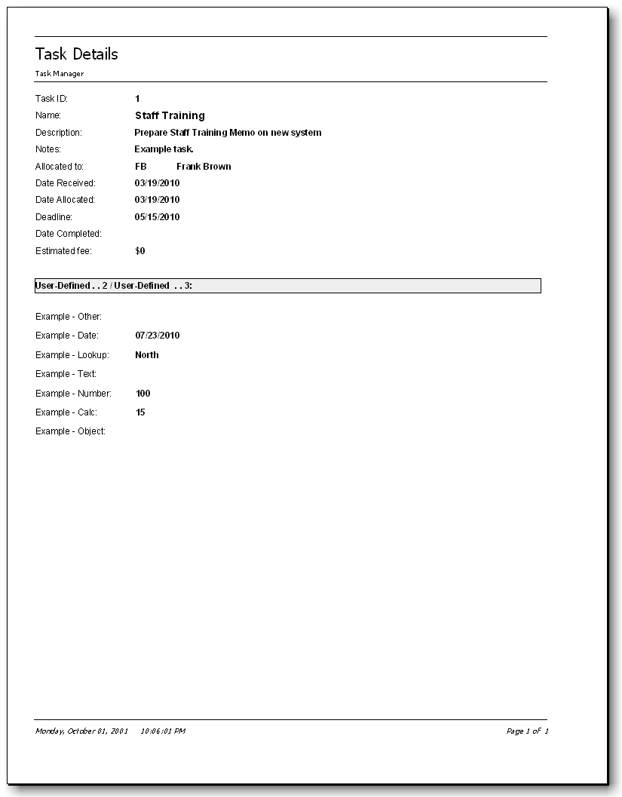

- Zoom-in to task detail for a close up look at a particular task's information.

Team Workload Overviews

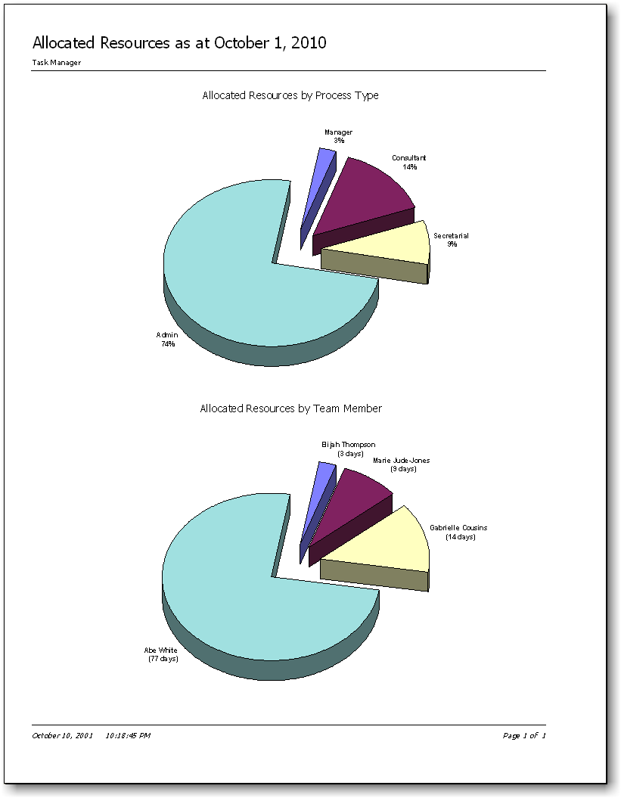

- Find out how much work each person in a team has and who is unfairly overloaded!

Analysis Tools

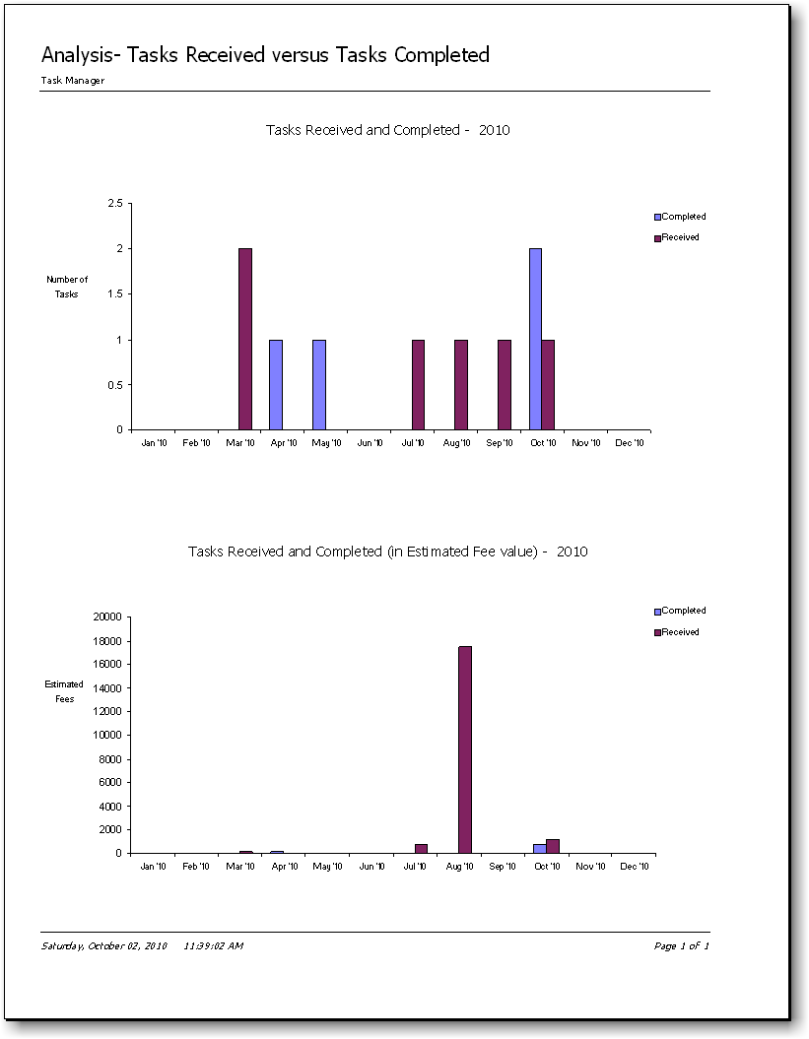

- Analyze current task workflow, task comparative workflow over five years, and more.

Interactivity with Task Calendar Views

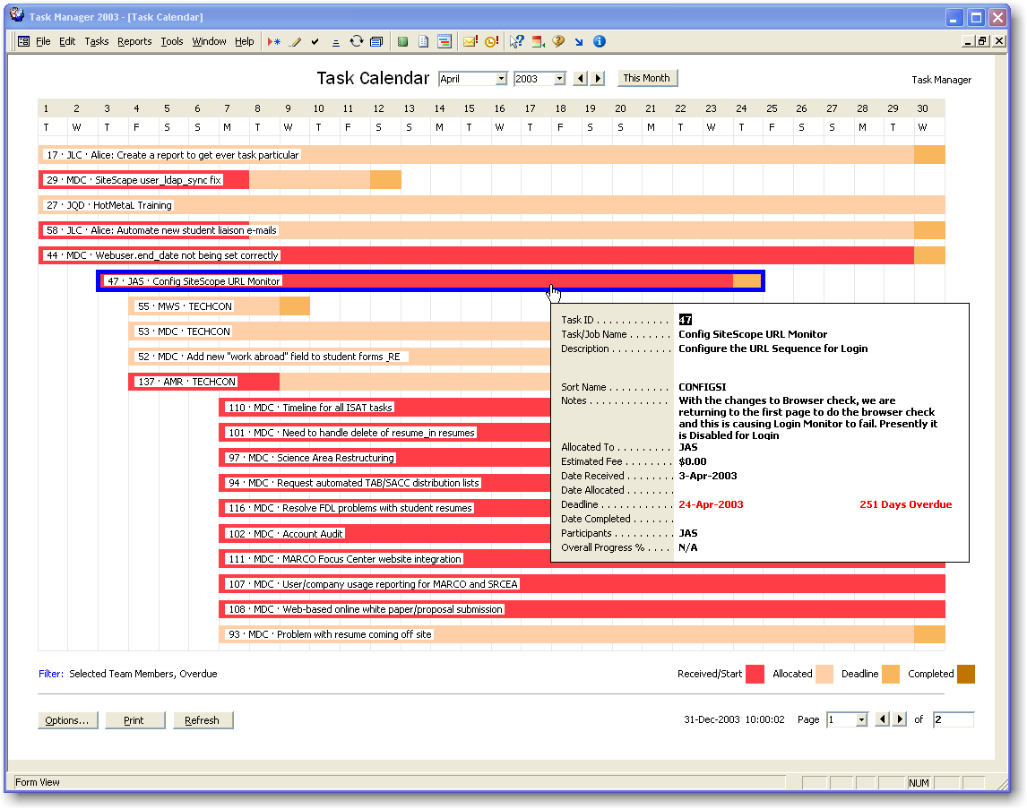

- Get a graphical view of all tasks, tasks for selected team members or a filtered selection of tasks.
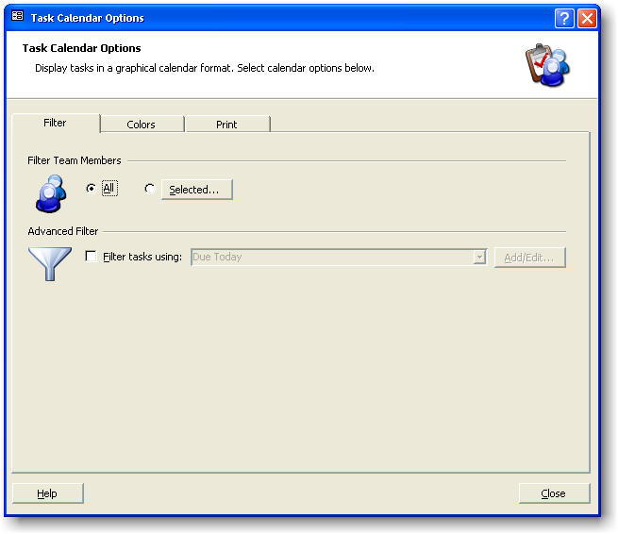

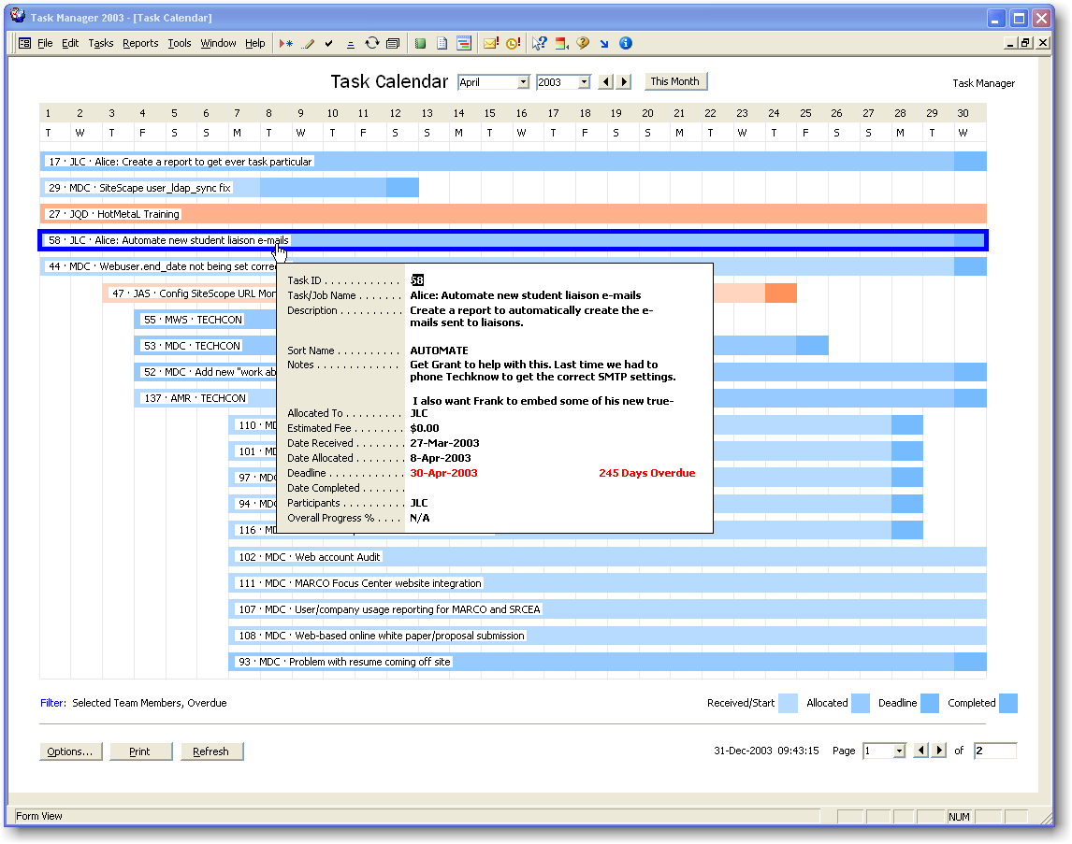

- Cycle bar colors on team member name or other built-in or user-defined fields.

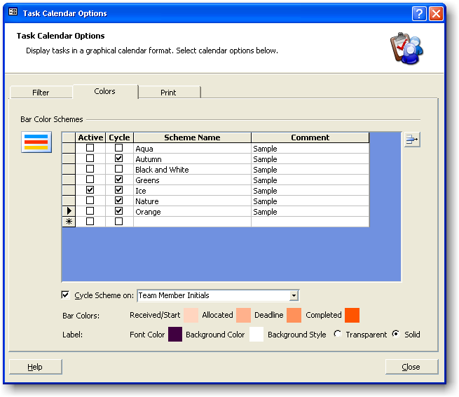

- Print a task calendar view if needed.
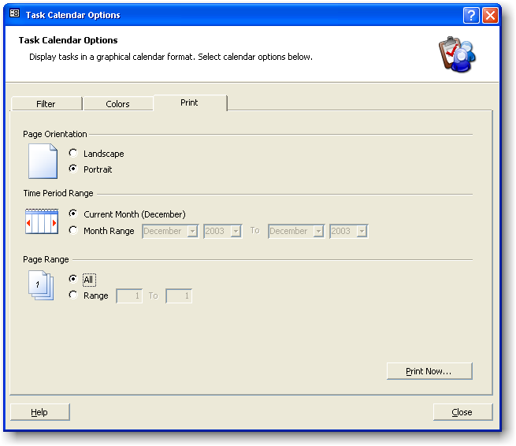

Improve Productivity with Auto-Scheduling

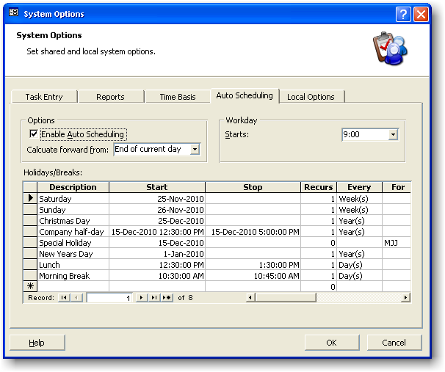

- Use Auto-scheduling to view suggested task start dates based on team member availability and workload.

Interrelate With Other Task Sources

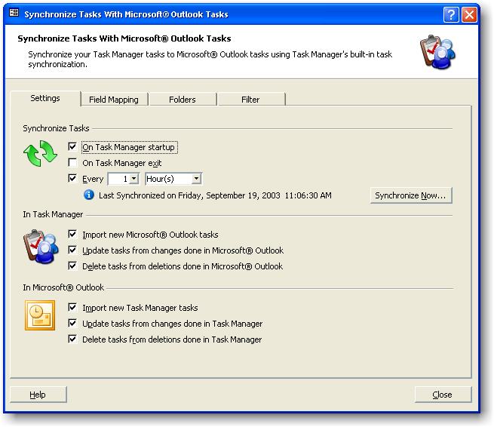

- Synchronize information with Microsoft® Outlook® tasks, Pocket PC® and other hand-held devices.

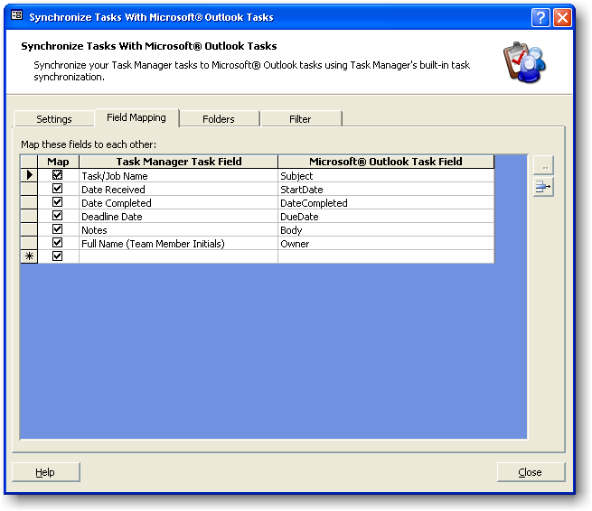
- Map Task Manager fields to Outlook® fields.

Activate Task Security: Program Permissions

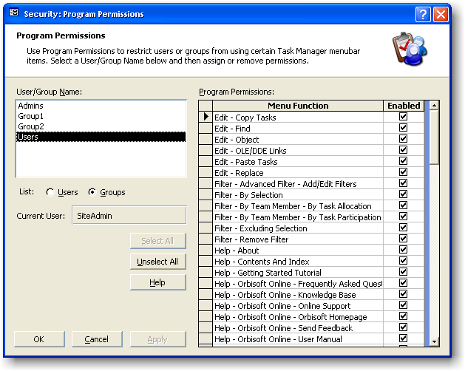

- Use Program Permissions to enable and disable selected menu items for particular users or groups. A disabled menu item will appear ‘dimmed’ and will be unusable by the particular user or group.

Activate Task Security: Field Permissions

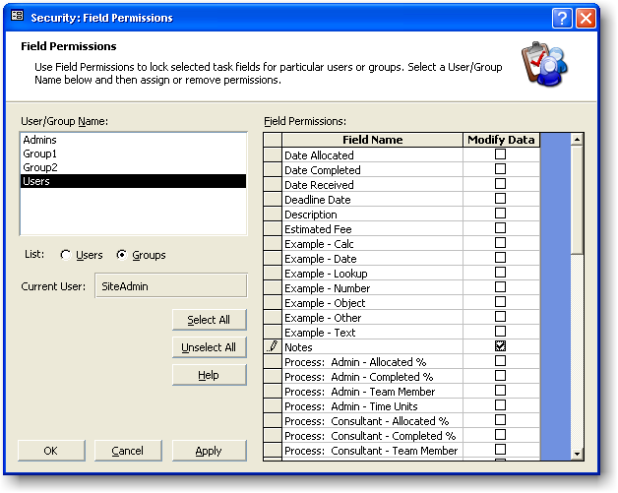

- Lock selected built-in or user-defined task fields for users or groups.

Activate Task Security: Task View Permissions

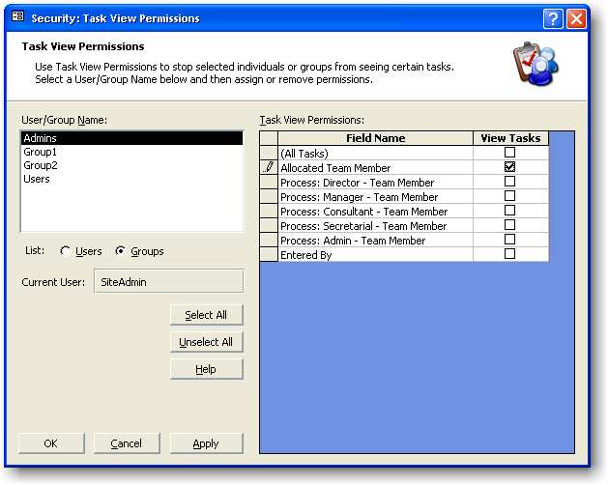

- Restrict users or groups from seeing other team member's tasks.

Use Built-in or Customized Email Reminders for Task Events

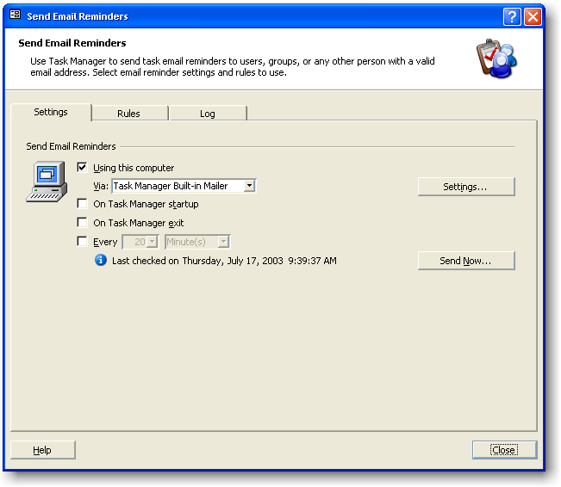

- Get Task Manager to send out automated email reminders.

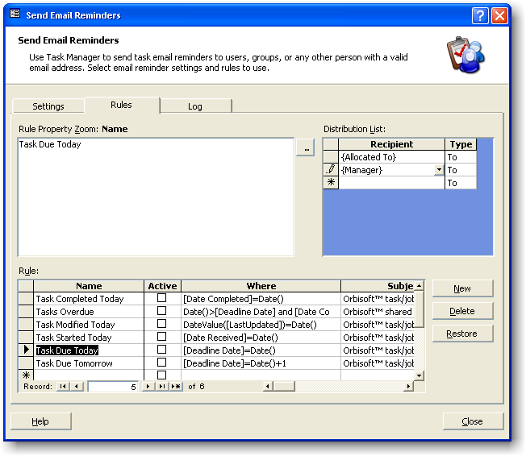

- Choose email reminder recipients such as task team members, static team members or any other persons (e.g. customers). Notify them that task deadlines are due, tasks are overdue, task data has changed, or any other important task milestone event has occurred.

Comprehensive Help with User Manual, Online Help And User Knowledge Base

- Quickly find the answers you need using online FAQ's, getting- started tutorial, knowledge base and a comprehensive user manual.

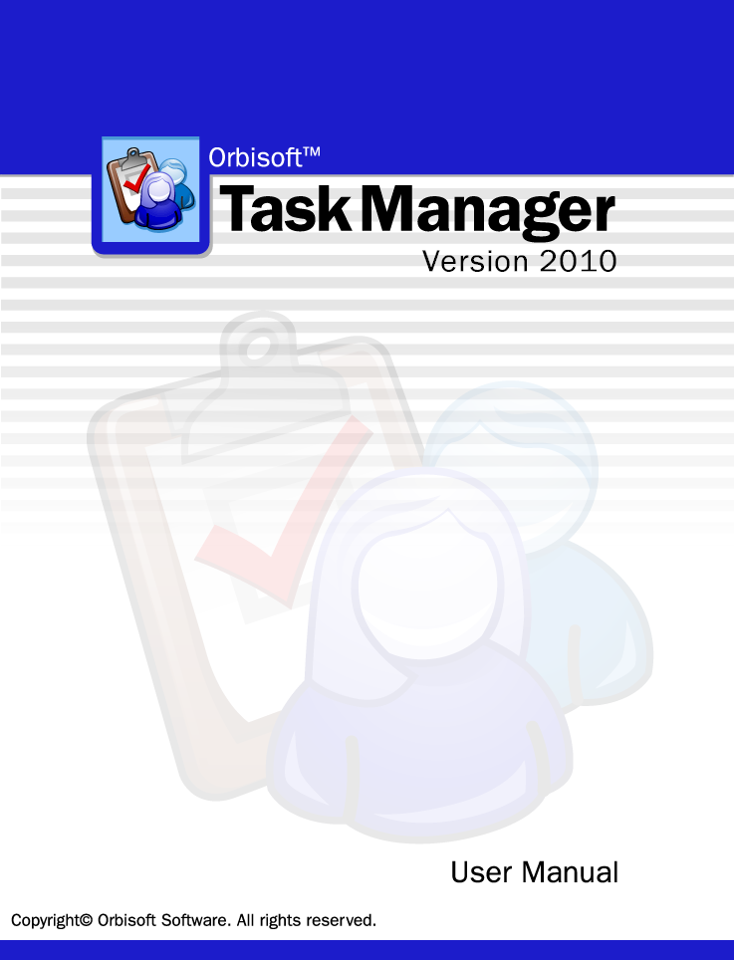

Sample Users
Recent purchasers include:

Industry | Organization | Location
Aerospace | Adria Airways | Ljubljana, Slovenia
Aerospace | Northrop Grumman | La Mesa CA
Agricultural Research and Promotion | Cotton Incorporated | Raleigh, NC
Bakery | Stroehmann | Williamsport, PA
Barcodes, security labels | Checkpoint Meto Kimball | Terborg, Netherlands
Biopharmaceuticals | Transkaryotic Therapies | Cambridge, MA
Casino | Horseshoe Gaming Holding Corp | East Chicago, IN
Computer-Hardware/Software | Omer Topoglu | Ankara, Turkey
Computer-Hardware/Software | Ilm Corp | Fredericksburg, VA
Computer-Hardware/Software | Wholewise Sci.&Tech.Co.,Ltd | FuZhou, China
Computer-Hardware/Software | Knoa.Com | New York, NY
Computer-Hardware/Software | Peoplesoft | Rutland, VT
Computer-Hardware/Software | Equanet | Surbiton, United Kingdom
Computer-Hardware/Software | Gsh Intelligent Integrated Systems | Weare, NH
Construction | Churchill & Banks | Providence, RI
Construction | Angelo Iafrate Construction | Warren, MI
Consulting | Ims Property Mgt. Consultation | Elk Grove, CA
Consulting | Francis W. Weir, Ph.D., Incl | Houston, TX
Consulting | Analytical Solutions | WINNETKA, CA
Consulting | Risk Management Systems Ltd. | Kemnay, England
Consumer Products | Lentek International | Orlando, FL
Courier | Fedex | Bartlett, TN
Courier | Ups | Paterson, NJ
Digital Video Server Systems | Seachange International | McDonough, GA
Education | Bryant College | Barrington, RI
Education | U.C. Berkeley | Berkeley, CA
Education | Brooklyn College | Brooklyn NY
Education | The Illinois Institute Of Art | Chicago, IL
Education | University Of Chicago/Gsb | Homewood, IL
Education | College Of Engineering -- University Of Wisconsin-Madison | Madison, WI
Education | Columbia University | New York, NY
Education | University Of California, Irvine Medical Center | Trabuco Canyon, CA
Education | Polytechnic Of Namibia | Windhoek, Namibia
Electronic Systems | Dc Audio Video Services | Portsmouth, NH
Industry | Organization | Location
Electronics - Medical - blood glucose monitoring, diabetes disease management | Sensys Medical | Phoenix, AZ
Energy/Utilities | Argonne National Lab | Argonne, IL
Energy/Utilities | Austin Energy (City Of Austin) | Austin, TX
Energy/Utilities | Exelon Thermal Technologies | Chicago, IL
Energy/Utilities | Duke Energy | Rock Hill, SC
Energy/Utilities | Northern California Power Agency (Ncpa) | Roseville, CA
Energy/Utilities | Nipsco | Valpariaso, IN
Engineering - Failure Analysis and Engineering Investigation | Mcswain Engineering | Cantonment, FL
Engineering - Failure Analysis and Engineering Investigation | Mcswain Engineering | Pensacola, FL
Financial/Insurance | Weaver And Tidwell, L.L.P. | Argyle, TX
Financial/Insurance | Mcgregor Bailey | Auckland, New Zealand
Financial/Insurance | Lee-Anne Ketchen | Blenheim, New Zealand
Financial/Insurance | Green Penklis & Lawson | Broadway, NSW, Australia
Financial/Insurance | Mutual Federal Savings | Chicago, IL
Financial/Insurance | Brownlee & Associates | Christchurch, New Zealand
Financial/Insurance | Citco Group | Cork, Ireland
Financial/Insurance | Rabo Financial Advisors | Dubbo, Australia
Financial/Insurance | Sho Chartered Accountants | Gloucestershire, England
Financial/Insurance | Pennsylvania State Employees Credit Union (Psecu) | Harrisburg, PA
Financial/Insurance | State Employees Credit Union (Secu) | Lansing, MI
Financial/Insurance | Henry Ricci CPA | MILLVILLE, NJ
Financial/Insurance | Stanislaus Credit Control | Modesto, CA
Financial/Insurance | Metlife (Metropolitan Life Insurance ) | New York, NY
Financial/Insurance | Metlife (Metropolitan Life Insurance ) | New York, NY
Financial/Insurance | Paul Vandal CPA | Old Mystic, Ct
Financial/Insurance | Goldin & Co | Pinner, United Kingdom
Financial/Insurance | Walsh Accounting | Queensland, Australia
Financial/Insurance | Wootton, King & Mulhern (Wkm) | Richmond BC, Canada
Financial/Insurance | Use Credit Union | San Diego, CA
Financial/Insurance | Lasry Corretora | Sao Paulo, Bouvet Island, Brazil
Financial/Insurance | Cibc | Surrey, Canada
Financial/Insurance | Malcolm Webster Limited | Tauranga, New Zealand
Financial/Insurance - Chartered Accountants | Carr & Stanton Ltd | Hastings, New Zealand
Freight | Northline Freight | Belair, Australia
Government-Federal | United States Library Of Congress | Washington DC
Government-Federal | US Department Of Agriculture - Farm Service Agency | Alexandria, VA
Government-Federal | Regulatory Authority For Energy | Athens, Greece
Government-Federal | Veterans Affairs Canada, Government Of Canada | Charlottetown, Canada
Government-Federal | Southwestern Power Administration | Tulsa, OK
Government-Federal | Bureau Of Prisons | Washington DC
Government-State/Local | Mta-Nyct | Brooklyn, NY
Industry | Organization | Location
Government-State/Local | City Of Carson City | Carson City, NV
Government-State/Local | Linn County Mis Dept | Cedar Rapids, IA
Government-State/Local | Mrci (Gouvernement Du Québec) | Montréal, Québec, Canada
Government-State/Local | City Of Mount Dora | Mount Dora, FL
Government-State/Local | City Of Port Adelaide Enfield | Port Adelaide, Australia
Government-State/Local | City Of Reno | Sparks, NV
Graphic Design | Tag Design | Santa Clara, CA
Health Care products | Waterpik Technologies | Fort Collins, CO
Health/Medical Services | Alabama Psychiatric Services Pc | Birmingham, AL
Health/Medical Services | Health Plus | Carle Place, NY
Health/Medical Services | Pilsen-Little Village Cmhc | Chicago, IL
Health/Medical Services | Ims Health, Canada | Pointe-Claire, Quebec, Canada
Health/Medical Services - Vet | Guilderland Animal Hospital | Altamont, NY
Healthcare | Baxter Healthcare | Round Lake, IL
Healthcare | Christus Primary Carenet | San Antonio, TX
Hotels/Casino | Isle Of Capri Casino & Hotel | Westlake, LA
HVAC | Shumate Mechanical | Duluth, GA
HVAC | The Trane Company | La Crosse, WI
IT | Copland & Associates Ltd | Auckland, New Zealand
IT | Prodx | Portland, OR
IT Consulting | Computer Sciences Corporation (Csc) | Frankfurt, Germany
IT Solutions | Red River Computer Company | Lebanon, NH
Legal | Carstens Yee And Cahoon | Coppell, TX
Legal | Lester & Mitchell, P.A. | Jacksonville, FL
Legal, Financial | Calmetta Manganelli Ricci | Milan, Italy
Manufacturing | Olin Corporation | Augusta, GA
Manufacturing | Cdi-Corp | Chicago, IL
Manufacturing | Bisazza | Miami, FL
Manufacturing | Dana Corporation | Oklahoma City, OK
Manufacturing | Carlson Systems | Omaha, NE
Manufacturing | Ash Grove Cement | Overland Park, KS
Manufacturing | Bmh Systems Inc | Quebec, Canada
Manufacturing | Springs Industries | Rock Hill, SC
Manufacturing | Yeuell Nameplate & Label | Stoneham, MA
Marketing | Tango Marketing, Llc | Edmonds, WA
Marketing Consultants | Oxxford Information Technology | Hagaman, NY
Medical research | National Institutes Of Health | Bethesda, MD
Military | Canadian Department Of Defense | Otawa, ON, Canada
Military | Eglin Air Force Base | Eglin AFB, FL
Military | Team C4Iews | Fort Monmouth, NJ
Network equipment design and manufacture | Chiaro Networks | Richardson, TX
Non-profit energy services organization | Vermont Energy Investment Corporation | Burlington, VT
Non-profit health maintenance organization (HMO) | Bluegrass Family Health | Lexington, KY
Non-profit organization | Community Options | Constantia, NY
Industry | Organization | Location
Other | International Lifestyles | Hollywood, FL
Packaging | Pactiv Corporation | Canandaigua, NY
Packaging | Superfos | Vipperød, Denmark
Personal | Niefra Beveiligingen | Amsterdam, Netherlands
Personal | Kamer Van Koophandel | Antwerp, Belgium
Personal | Tracey L Taylor | Arkansas City, KS
Personal | Wayne Pease | ASHLAND, MA
Personal | Lynda Moore Accountants | Auckland, New Zealand
Personal | M K Handisides & Associates | Auckland, New Zealand
Personal | Jeffrey E. Read | Aurora, CO
Personal | Robbie Kuemmel | Austin, TX
Personal | Perverts | Belo Horizonte, Brazil
Personal | Marcel Wyler | Bern, Switzerland
Personal | Dma Lighting Inc | Boise, ID
Personal | Clarín.Com | Buenos Aires, Argentina
Personal | Rodger Aiers | Burnaby, Canada
Personal | Beach Ford Inc | Dalivants Ferry, SC
Personal | Andrew Goodwin | Dartmouth, Canada
Personal | Denese Williams | Detroit, MI
Personal | Shandwick International | Essex, England
Personal | Edward A Raha | Fairfield, CT
Personal | Ptg, Inc. | Fountain Valley, CA
Personal | Melvin C Spain | Franklin, TN
Personal | Pamela Calvin | Fredericksburg, VA
Personal | Christopher Heath | Gilroy, CA
Personal | Sara Massagee | Hendersonville, NC
Personal | John Camp | Houston, TX
Personal | Sean Cafferky | Houston, TX
Personal | Maxwell Shoe Company, Inc. | Hyde Park, MA
Personal | Dr. Meir Noam Advocate & Patent Attorney | Jerusalem, Israel
Personal | David Throop | Joplin, MO
Personal | Tudor Marsden-Huggins | Kenmore, Australia
Personal | Della J Gottesman | Laurel, MD
Personal | Ian Scott | Liverpool, Merseyside, United Kingdom
Personal | Allen Kreiser | longmont, CO
Personal | Pharris Cockrell | Louisville, MS
Personal | City Of Lowell, Massachusetts | Lowell, MA
Personal | Charles Olson | Lynnwood, WA
Personal | Myles Foreman | Macleod, Australia
Personal | Bureau Of Meteorology | Melbourne, Australia
Personal | Lisa Laing | Melbourne, Australia
Personal | Ali Nasser | Mississauga, Ontario, Canada
Personal | Richard Baker | New York, NY
Personal | Kim Torgerson | Oakland, CA
Personal | Andreas Roshop | Oldenburg, Germany
Industry | Organization | Location
Personal | Christina Goodwin | Orlando, FL
Personal | Nettavisen As | Oslo, Norway
Personal | Lisa Karnes | Ozana, TX
Personal | Matt Mckee | Richardson, TX
Personal | Brian Genter | Rochester , NY
Personal | Alan Manchester | Rotherham, United Kingdom
Personal | 2Wire, Inc. | San Jose, CA
Personal | James Butts | Santa Rosa, CA
Personal | Adam Barnes | Seatle, WA
Personal | Frederick Nelson | Seekonk, MA
Personal | Sarah Hill Buck | Snyder, NY
Personal | Louis P Filippelli | South Kingstown, RI
Personal | Hal Bird | South Lake Tahoe, CA
Personal | Bruce Wagner | Southfield, MI
Personal | James Bunce | Spencerport, NY
Personal | Joe Mastriano | Sugarland, TX
Personal | Joseph Perrino | Tacoma, WA
Personal | Library Of Congress | Washington DC
Personal | Sba - Offc. Of Disaster Assistance | Washington, DC
Personal | Catherine J. Ekwinski | Yorkville, IL
Pharmaceuticals | Maxam Nutraceutics | Hood River, OR
Pharmaceuticals | Aventis | RTP, NC
Plastic bag , pouch equipment | Hudson-Sharp Machine Company | Green Bay, WI
Process Systems | Kinetics Group | Burleson, TX
Real Estate | Jones Lang Lasalle | Chicago, IL
Real Estate | Hanover Company | Houston, TX
Real Estate | Murphy & Mcmanus, Llc | Needham, MA
Retail | Sanford Corporation | Bellwood, IL
Retail - Sporting goods | Dicks Sporting Goods | Pittsburgh, PA
Scientific/R+D | Semiconductor Research Corporation | Research Triangle Park, NC
Services | Larrys Plumbing | Dallas, TX
Software - database | Mysql Ab | Mansfield, United Kingdom
Technical contractors | Mechanical Service Corporation | Whippany, NJ
Telecommunications | Ericsson | Celina, TX
Telecommunications | Ameritech | Grand Rapids, MI
Telecommunications | Space Systems/Loral | Palo Alto, CA
Trust Fund | Csea Employee Benefit Fund | Latham, NY
Wildlife Conservation | National Wildlife Federation | Cross Junction, VA

Task Manager 20|20 Online Information
- Visit www.orbisoft.com to see the following additional online information:

Online Tutorial
http://www.orbisoft.com/tutorial

Online Frequently Asked Questions (FAQ's)
http://www.orbisoft.com/faq

Online Product Information
http://www.orbisoft.com

Online Support Information
http://www.orbisoft.com/support

Free 45-Day Trial Download
http://www.orbisoft.com/download

Downloadable Color User Manual
http://www.orbisoft.com/manual

Support Knowledge Base
http://www.orbisoft.com/kb

User Comments
See what users are saying about Task Manager:

"My boss loves the app"
Taylor Suchan
IT Support
Carstens Yee and Cahoon LLP

"I love this product"
Dave Hooper
IT manager
Novartis

"Hey love your product"
Steve Howell
Web Marketing Technology Manager
International Lifestyles/ SuperClubs

"I love your product. I am trying to make this work seamless to allow a large multi license purchase."
John Schinter
Exelon Thermal Technologies
Chicago, IL

"Congratulations on creating such a unique and useful product."
Carl Johnson
Secure Records

"So far I love the program"
Marilyn Tamblyn

"Just downloaded the trial version - WOW!"
Jen Davis
Sr. Software Engineer
Stars-SMI

"I love the flexibility."
Lisa Simpkims
Technical Writer\QA Analyst
Fulbright & Jaworski L.L.P.

"a great product."
Marshall Bowden
I/T Specialist, IBM Global Services

"...it is a great product."
Michele Borrelli
Goalquest

"Great Product..."
David Phan

"excellent,now that's what I call service, all seems pretty clear so far, I like the program, but I may get in touch if there is any concerns, thanks again"
Gary Rushton

"...the "Quick" toolbars in the menu bar are a perfect revision to an excellent product."
Schinter, John (US)
Director of Operations
Exelon Thermal Technologies
Chicago, IL

"Thank you for your excellent response to my needs."
David A. Copestakes

"The program is easy to use and your support has been excellent."
John Hieb
Manager, Migration Services
Fios Inc
Portland, Oregon

"I just love the personal attention I get from you!"
Lynn Benson
Edward H. Gilbert, P.A.
Boca Raton, FL

"It looks a very good product.."
Derek

"you guys did a great job on the help..."
Winston Foley
IT Manager
National Wildlife Federation

"lot of great features"
Isabel Rodriguez

"It's a fine piece of software..."
Daniel Verheyen

"The new features are great!"
Norm Prevett
Jenica Corporation
Nashua, NH

"Greatly appreciate your product"
Ed Raha
Managed Quantitative Advisors

"I especially like the reporting features - perfect."
Carol Aton

"Your customer support is outstanding!!"
Larry Franks
Peterborough Utility Services
ON, Canada

"[I am] impressed"
Richmond Rice

"[I'll be] recommending your product to others and letting them know my positive impressions of it."
Lois Scheidt

"Now this is impressive....I have many questions and, as with most "free trials", assumed there was no recourse but hard to find/understand help manuals. What a refreshing approach!"
[Regarding personal customer care support assignment]
Michael Smith

"fine product"
Captain Chow
Canadian Department of Defence
Otawa, ON
Canada

"This is the easiest and most comprehensive task manager I have seen!"
John Hieb
Fios Inc
Portland, OR

"I am very impressed with the program"
Gary Osborn
Senior Quality Engineer
Dormont Manufacturing Co.
Export, Pennsylvania

Pricing
- View the latest Task Manager 20|20 pricing schedule at www.orbisoft.com/purchase




Ziff-Davis Tucows Organizers HR-Guide/Software
5-Star Editors Pick 5/5 Gold Rating 4/4 Rating

Contact
- Contact us today for more information.
Orbisoft Pre-Sales Support Team
Email: presales@orbisoft.com

- To purchase, go to www.orbisoft.com/purchase
Orbisoft Software Corporation
Email: presales@orbisoft.com
Web: www.orbisoft.com

